Tasks
1.
Create a table comparing Authentication, Authorization, and Accounting (AAA) by listing at least two real-world examples of each function from popular apps like Instagram, Zomato, or Paytm.
>
AAA Function | Definition | Example 1: Instagram | Example 2: Zomato
Authentication | Verifies the true identity of a user attempting to access the application. | Typing your username and matching password, or using FaceID to log into your account. | Entering your mobile number and verifying it with a dynamic 6-digit OTP code sent via SMS.
Authorization | Determines the specific permissions and actions a verified user is allowed to perform. | Allowing you to view private accounts you follow, but blocking you from modifying another user's posts. | Allowing a customer to place an order, but allowing a delivery rider to update the status to "Delivered".
Accounting | Keeps a running log of user activities, session durations, data usage, and transaction histories. | Tracking how long you spend on the app, matching your search history to build an ad profile, and logging logins. | Recording a definitive transaction receipt showing the Order ID, timestamp, items bought, and payment success status.

2.
Draw a simple network diagram showing how AAA is used to secure access to a WiFi network in a college campus, labeling where authentication, authorization, and accounting take place.<br><br><em><strong>Hint:</strong> Include devices like user laptops, access points, AAA server, and the internet gateway.</em>

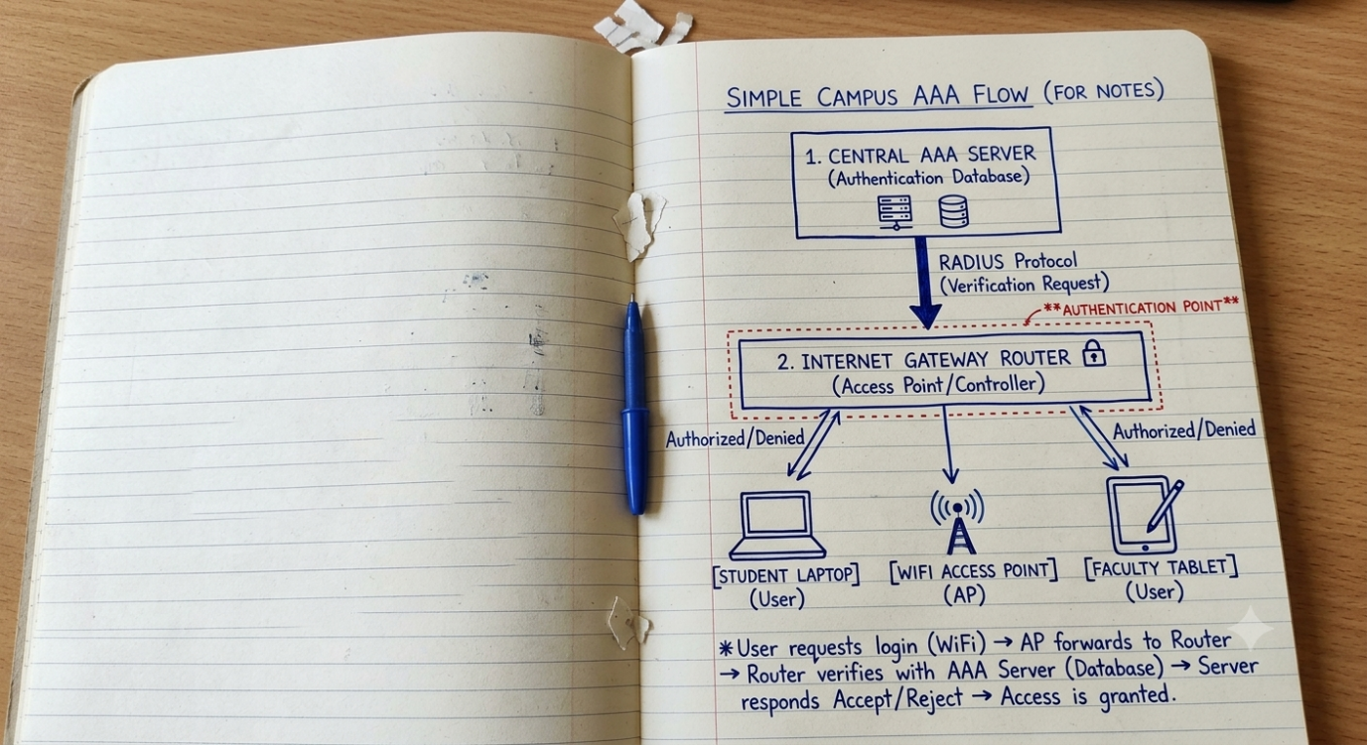

3.
Explain the difference between centralized and distributed AAA deployment models by describing how each would work in a scenario where multiple Flipkart warehouses need secure network access.
>Flipkart needs to manage secure network access across multiple large physical warehouses across the country, the two deployment models operate differently:
- Centralized AAA Model: All warehouse network switches and scanners connect to a single central AAA server located at the corporate headquarters or main cloud database. When a warehouse worker scans a barcode badge to log in, the local terminal queries the central server over the WAN.
  - Difference: Highly uniform and easy to manage, but if the main internet connection at the warehouse drops, the worker cannot authenticate or perform work.
- Distributed AAA Model: Each individual warehouse houses its own local physical AAA server node inside its data server closet.
  - Difference: If the main company internet goes down, the local warehouse operations continue completely unhindered because logins are handled locally. However, maintaining and syncing updates across dozens of individual warehouse servers is much more complex and costly.

4.
Pick any one AAA deployment model and list three advantages and two disadvantages of using it for a large-scale app like BookMyShow.
>
For a massive customer-facing application like BookMyShow that handles millions of high-traffic ticket requests simultaneously, a Centralized Cloud-based AAA model is utilized.
Advantages
- Real-time Synchronization: When high-demand movie or concert tickets drop, centralized databases prevent synchronization lag. A user's seat reservation status updates instantly across all servers simultaneously.
- Simplified Fraud Prevention: Because transaction and session logs are funneled into one secure main location, auditing security events and blocking suspicious accounts or bulk-buying botnets is much faster.
- Consistent Policy Management: Security teams can easily push critical system-wide credential policies or payment token protocols globally with a single deployment action.
Disadvantages
- Impact of Outages: If the central AAA service cluster encounters an infrastructure outage, no user nationwide can authenticate, browse tickets, or finalize payments.
- Network Latency Under Peak Loads: During massive booking surges, long network round-trip paths to a distant centralized server cluster can slow down user responses, resulting in time-outs.

5.
Use ChatGPT or another AI tool to generate a sample AAA policy for a Zomato-like app, specifying what actions are authenticated, which roles are authorized for each action, and what accounting logs should be kept. Paste the generated policy and highlight one thing you would change to make it more secure.
>Application Security Policy
POLICY REF: ZM-AAA-SEC-2026
SCOPE: Customer and Delivery Partner Platforms
- Authentication: All access requests require active verification. Customers authenticate using Multi-Factor Authentication (OTP verification over SMS/Email). Delivery partners must authenticate using a combination of passwords and device-registered hardware biometrics.
- Role-Based Authorization Constraints:
  - Role: Customer — Authorized to browse restaurant menus, track assignments, and execute personal payments. Completely restricted from modifying restaurant price files.
  - Role: Delivery Partner — Authorized to view designated delivery routes and update delivery status flags. Completely restricted from viewing customer payment methods.
- Accounting Audit Standard: The system records active transaction logs containing unique transaction tokens, user ID mappings, timestamps, geolocation parameters, and payment confirmation statuses. Logs are retained for 365 days.
Security Hardening Recommendation (Making it More Secure)
To make this policy considerably more robust, I would add Context-Aware Adaptive Authentication.
Instead of allowing standard access simply because the user provided a correct OTP code, the system should dynamically analyze contextual indicators like unusual device geolocation changes or simultaneous logins from distant physical locations. If a delivery partner tries to sign in from two separate cities within a short timeframe, the central system will flag it as anomalous, immediately restrict authorization privileges, and prompt for additional verification steps.

